7/29/2022

Sumit Mishra

SIC: 190310286

Project-01

**Topic :** Configure more than one webserver with proper load balancing, auto scaling and SSL configuration.

## Creating and configuring a VPC.

1. Create a VPC



1. Create a subnet inside the VPC to host servers.

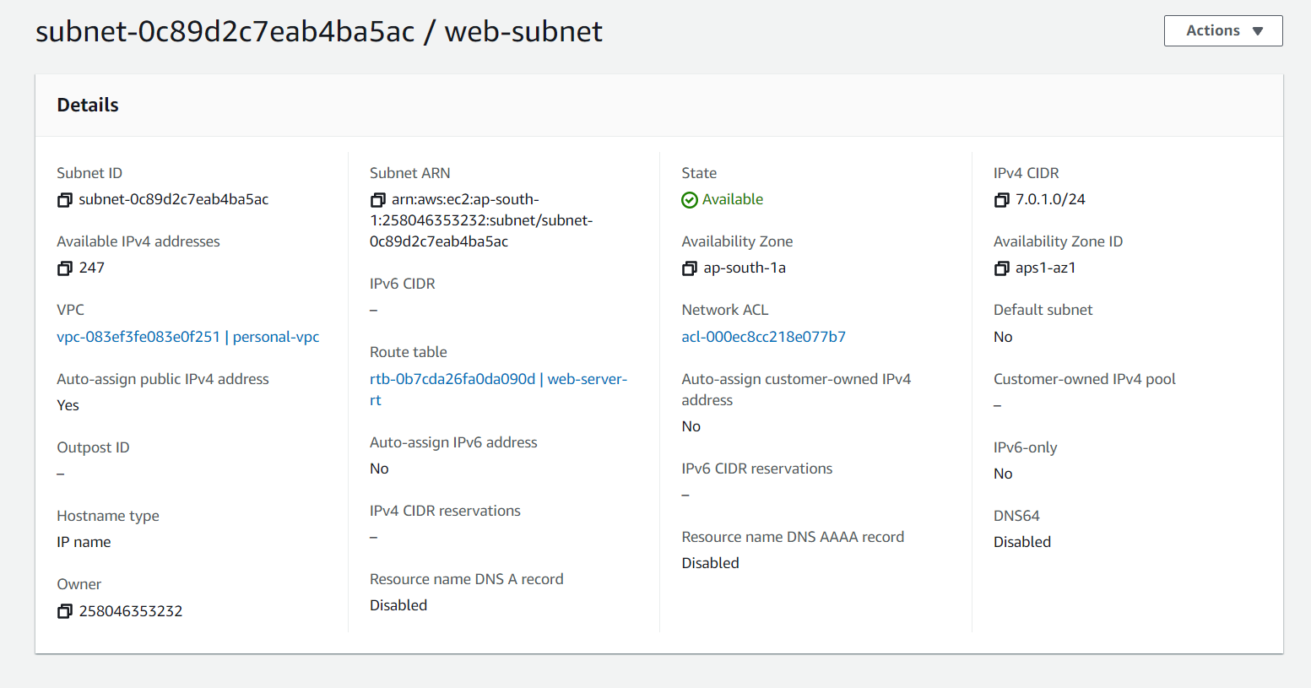

1. Created an Internet Gateway for the servers to access the internet through it.

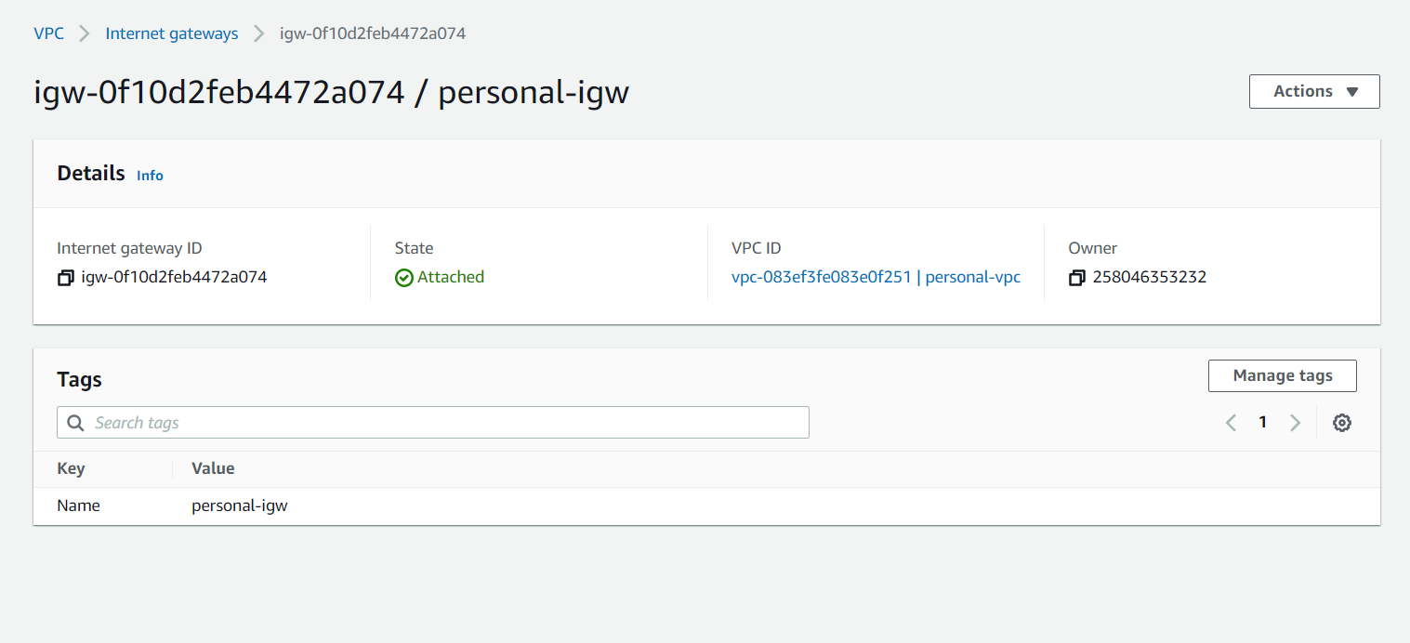

1. Created and configured the route table for the subnet created.

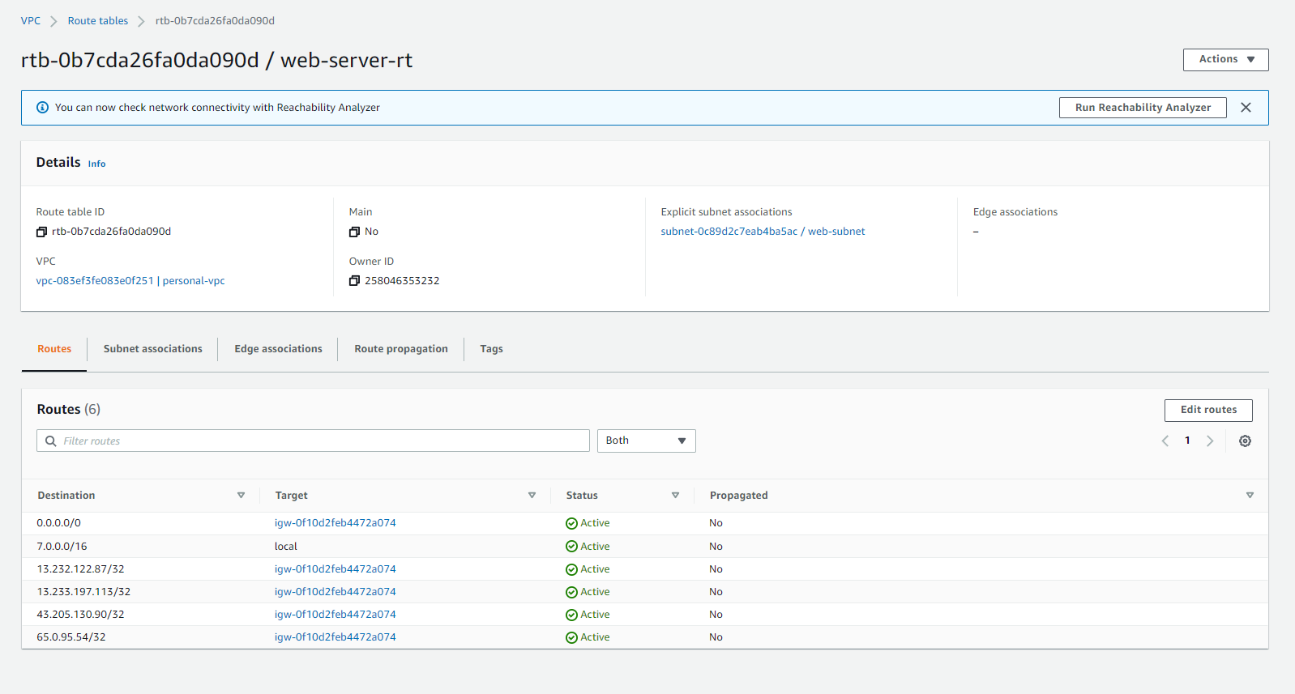

## Configuring Web servers, domain, hosting.

1. Launching 4 EC2 instances with Linux AMI.

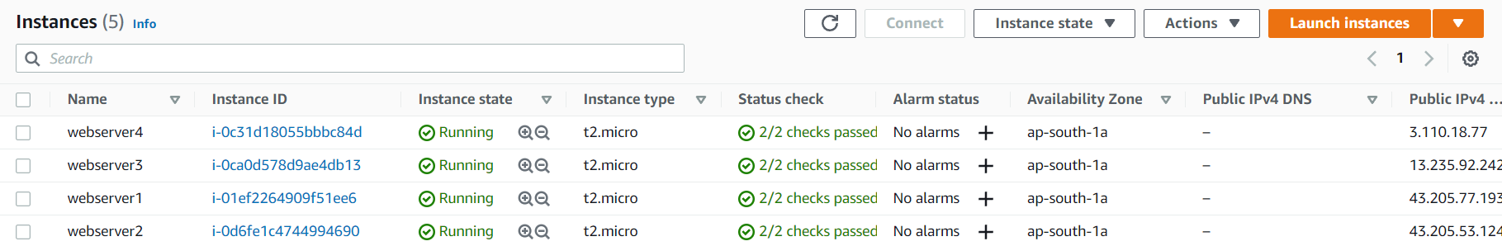

1. Assigning Elastic IP addresses to all the four servers.



1. Creating a Hosted zone in AWS Route 53 and adding hosting records for root domain(sumitmishra.info) and sub-domain(www.sumitmishra.info).

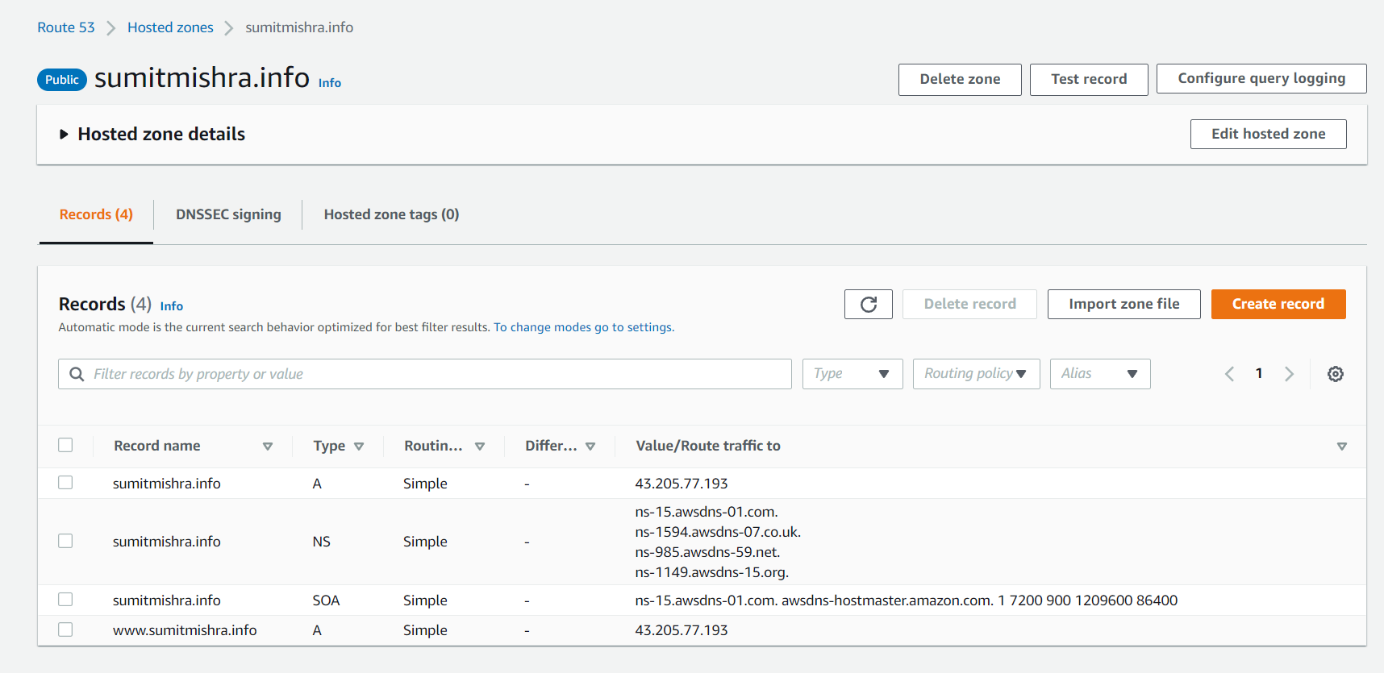

1. Replacing Nameservers in GoDaddy Domain (sumitmishra.info) with AWS Route 53 Nameservers.

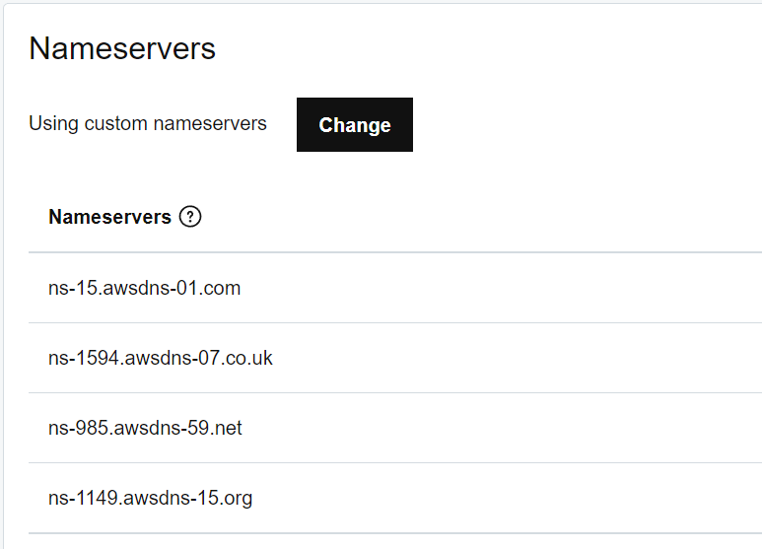

## Configuring SSL/TLS certificate for a webserver using let us encrypt Apache certbot.

1. Opening the website hosted in webserver one without SSL/TLS certificate we get the not secured warning in the left most side of URL bar.



1. Now configuring the SSL certificate through let’s encrypt using ssh client.

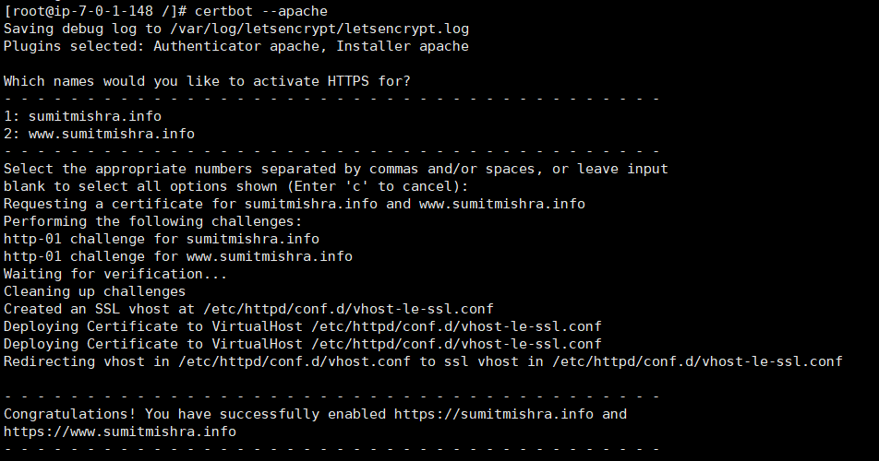

1. Now again hitting the URL sumitmishra.info and www.sumitmishra.info to see that the website shows secured in the leftmost area of the URL bar, this means that SSL certificate has been enabled.



## Creating a target group using the four servers and configuring load balancing along with SSL certificate using let’s encrypt for the load balancer.

1. Creating a target group.

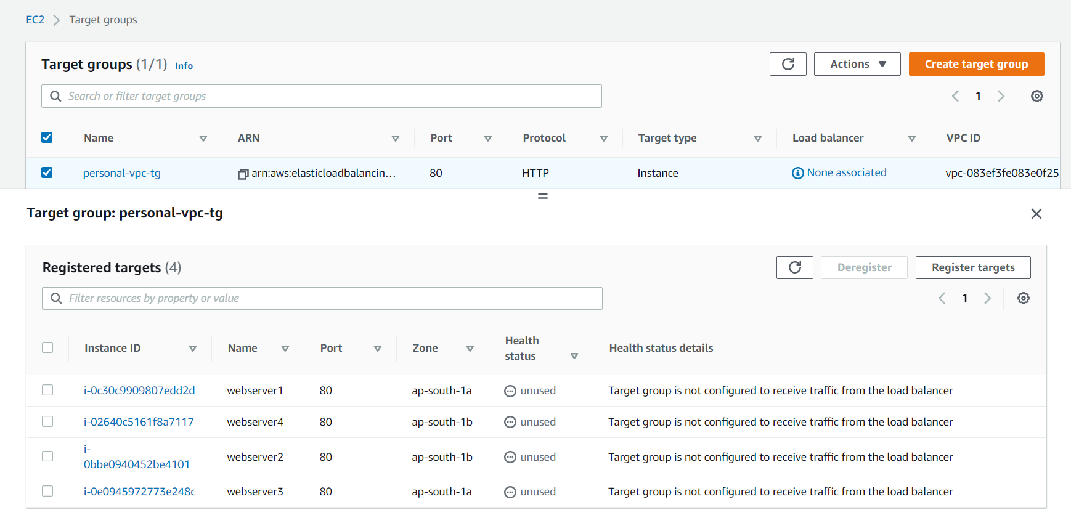

1. Creating a load balancer.

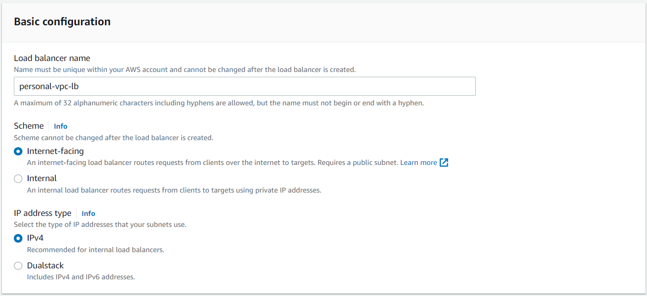

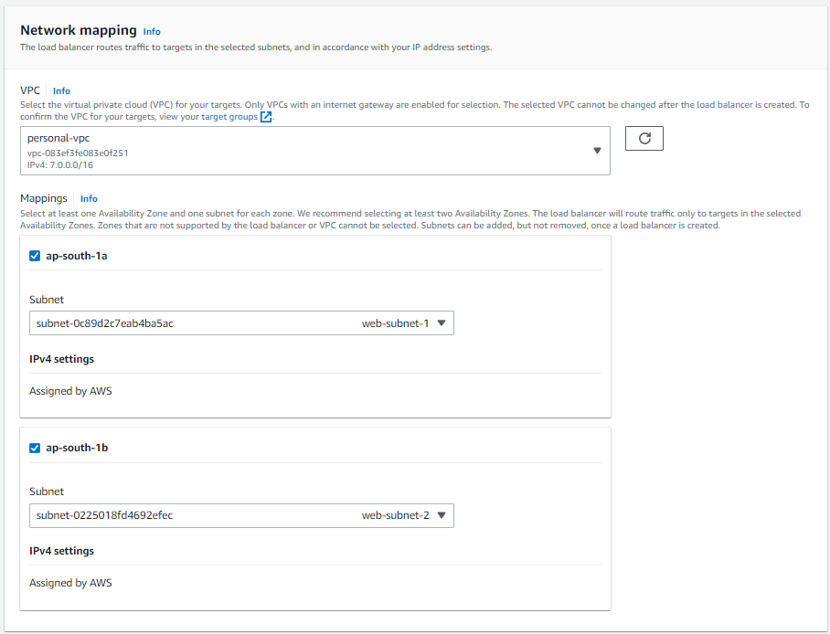

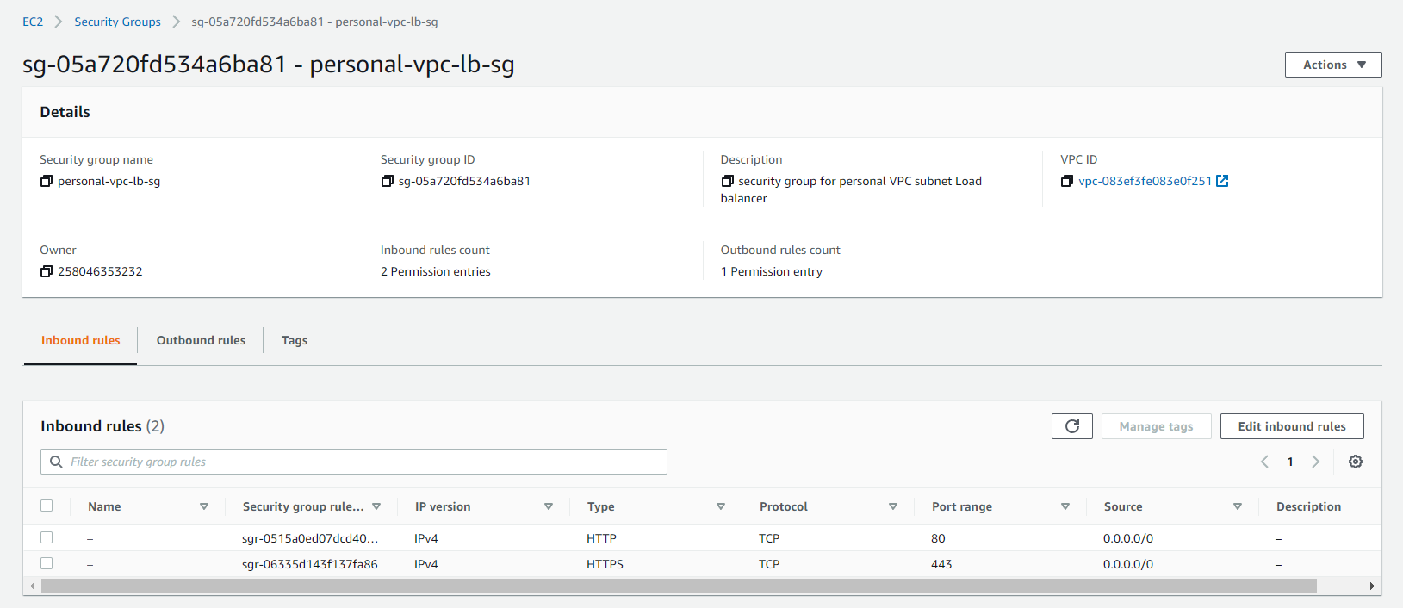

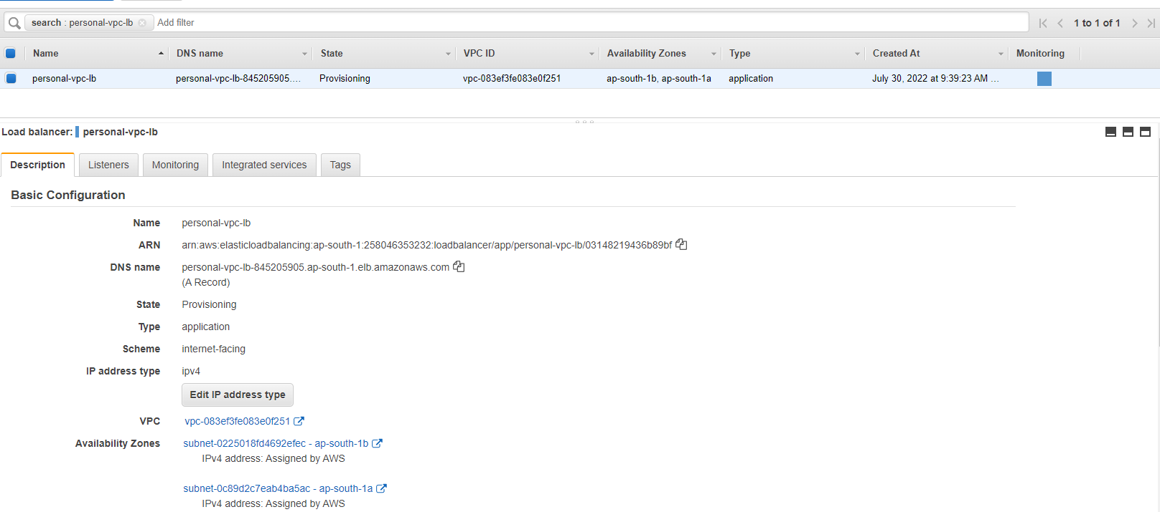

1. Creating a new sub-domain and associating the load balancer’s DNS to that domain name.

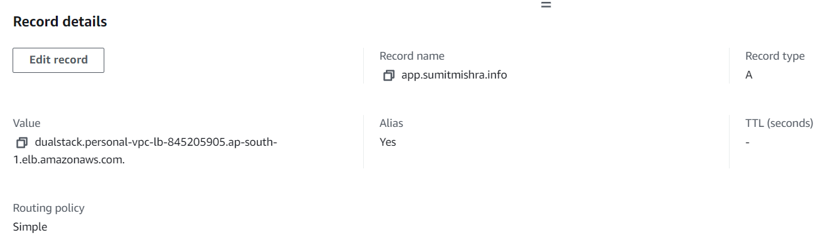

1. Server is distributing the traffic, but SSL certificate has not been configured.

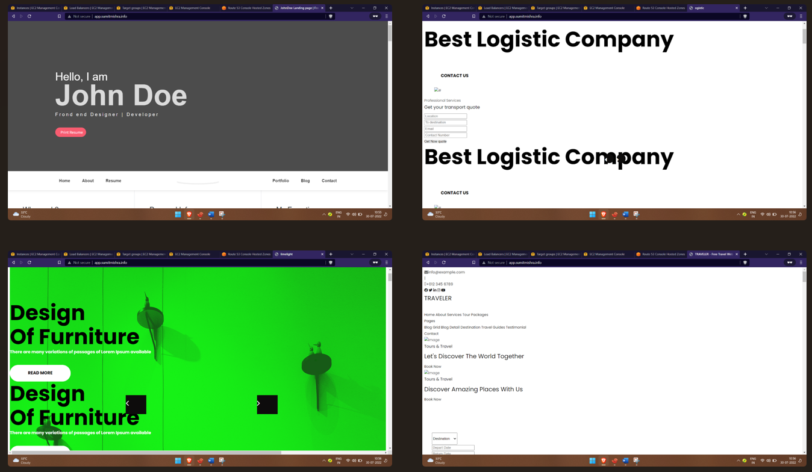

1. SSL configuration using AWS Certificate Manager.
   1. Request a certificate.

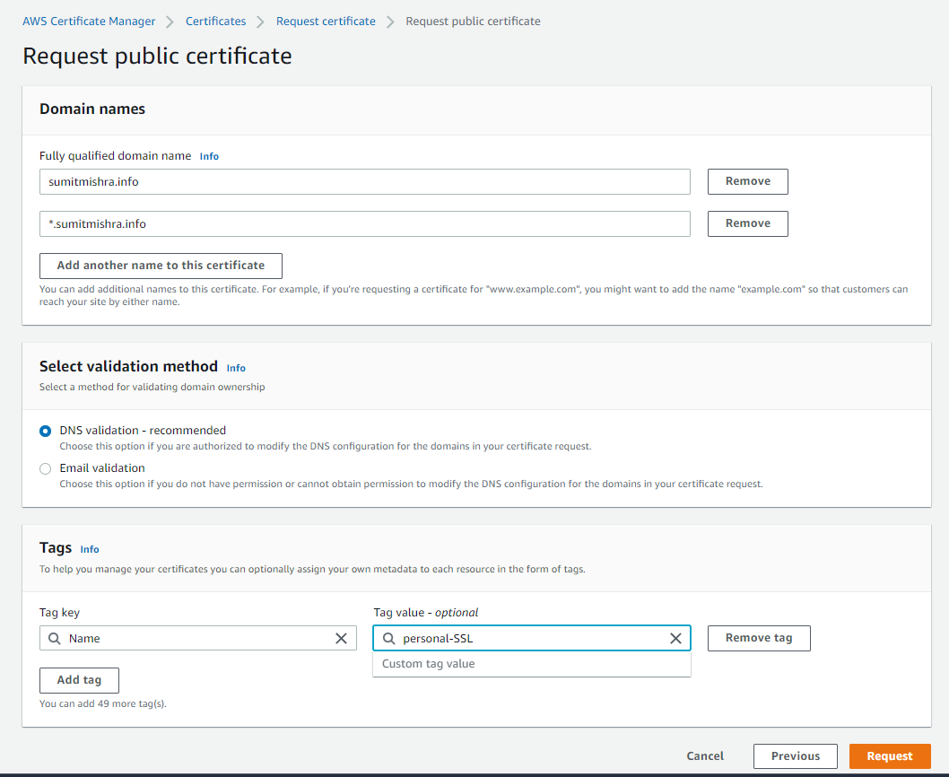

* 1. After requesting, add the records to the route 53 table.

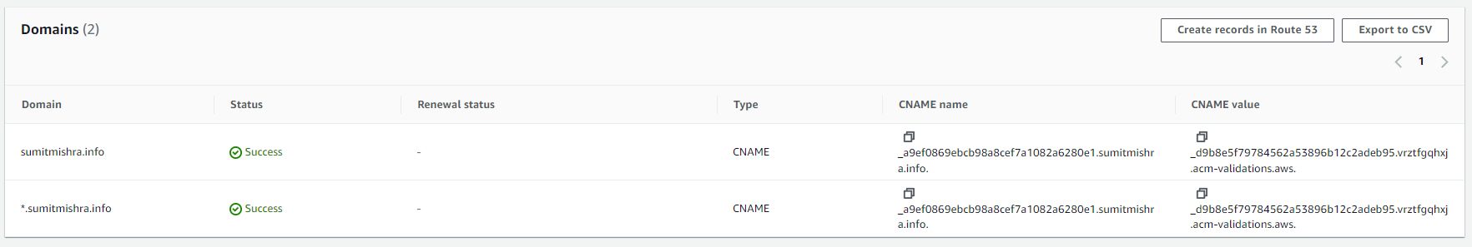

* 1. After certificate has been issued, go to load balancer -> listener -> add new listener -> select https and forward it to target group created and select the certificate as the created one.

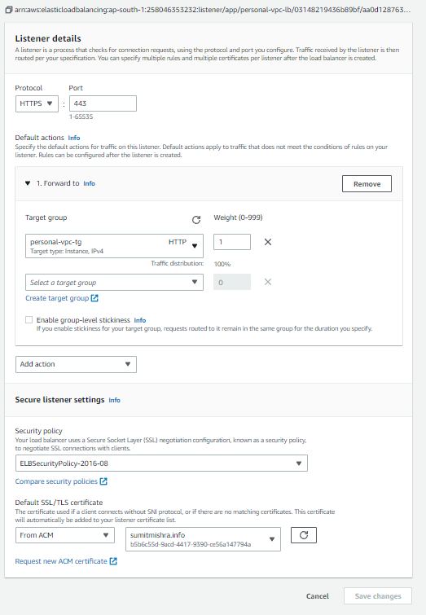

1. SSL has been successfully enabled if we hit the URL with <https://app.sumitmishra.info> and load is balanced between the backend web servers.



## Configuring auto scaling to an instance.

1. Create an Image of webserver1 EC2 instance.

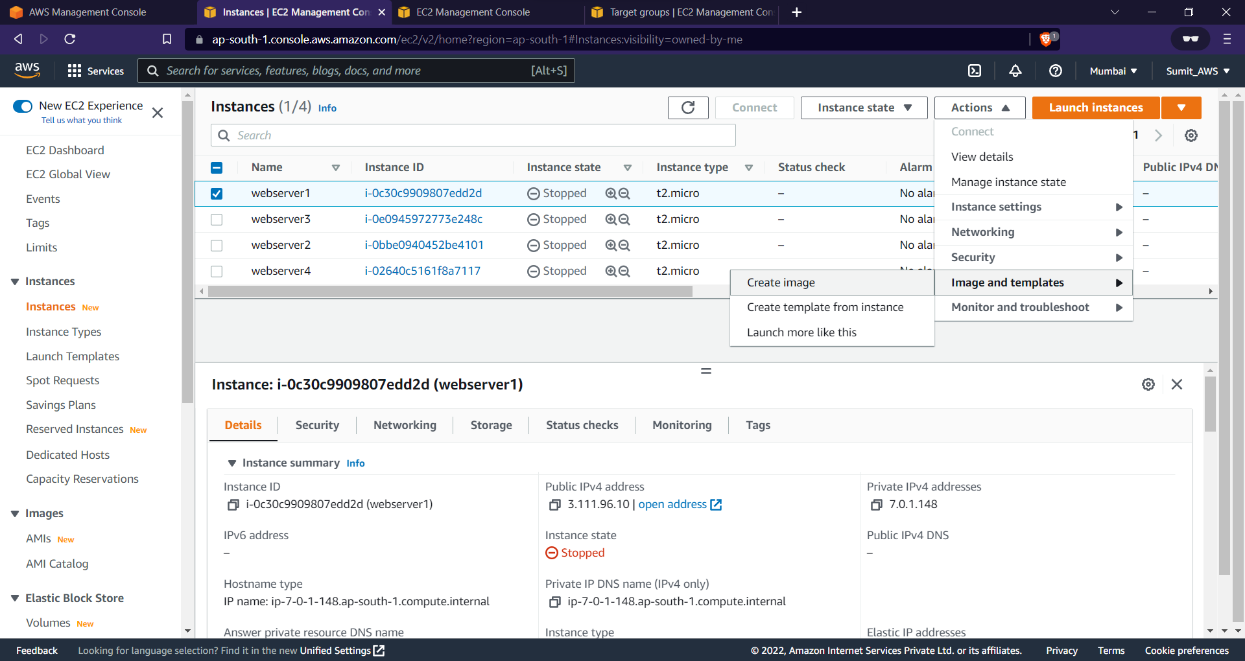

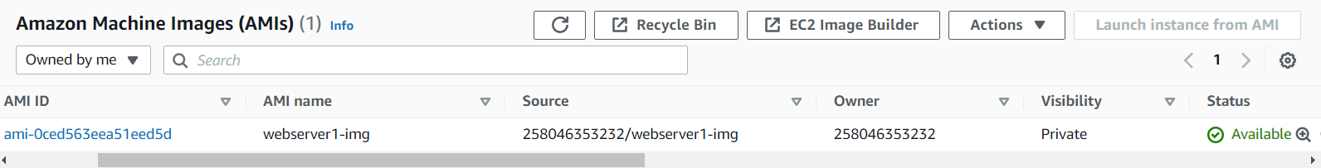

1. Create a new Load balancer “webserver1-lb” specifically for that server and assign a new configured target group for the “webserver1-tg” not having any instance attached to it.

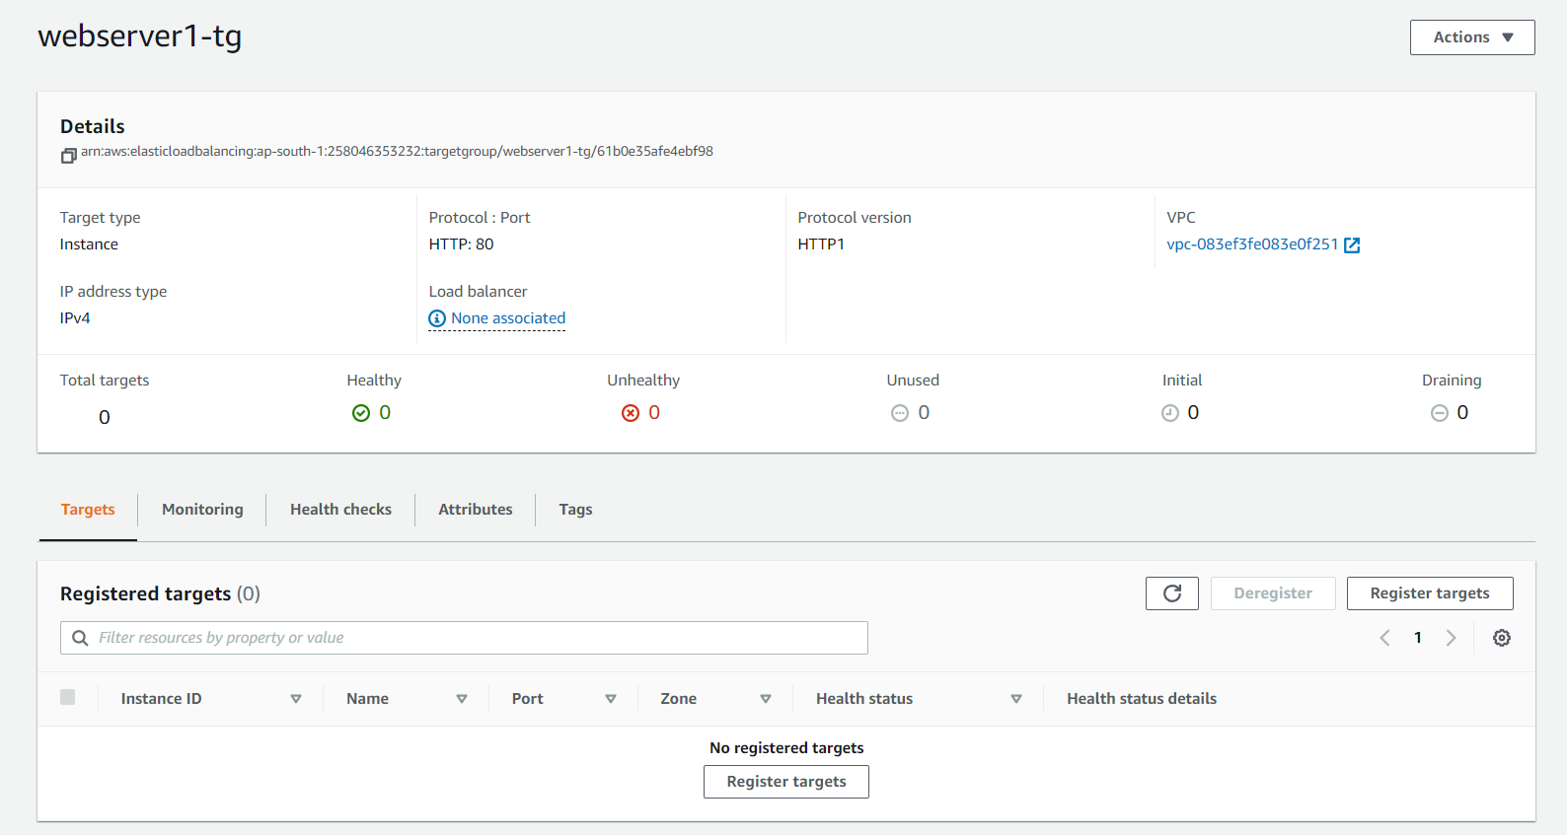

1. Now, created a new launch configuration using image of the “webserver1” instance and also checking on the option of detailed monitoring using AWS cloudwatch.

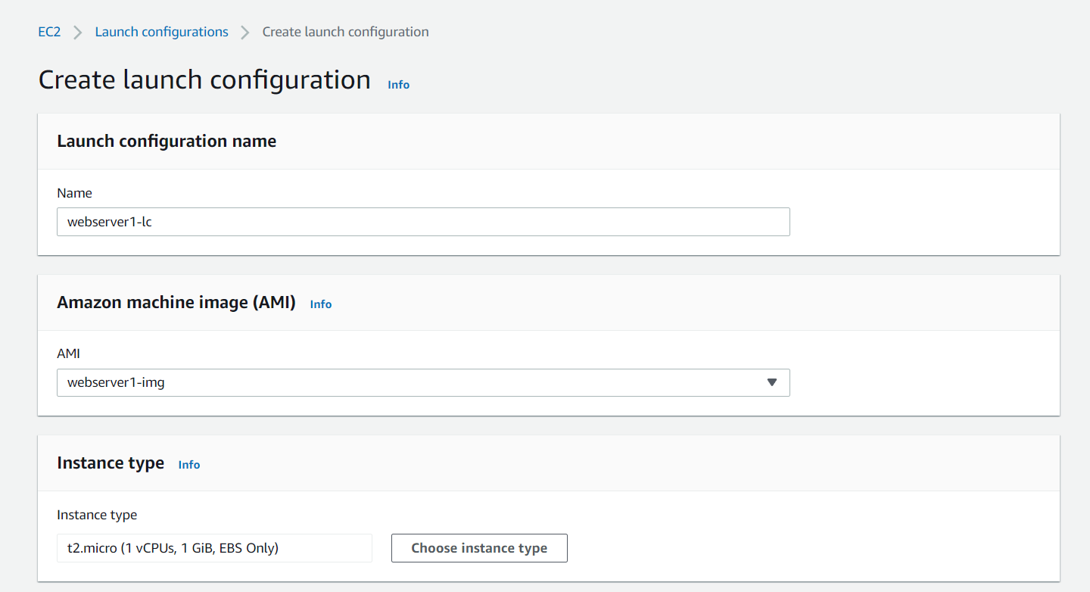

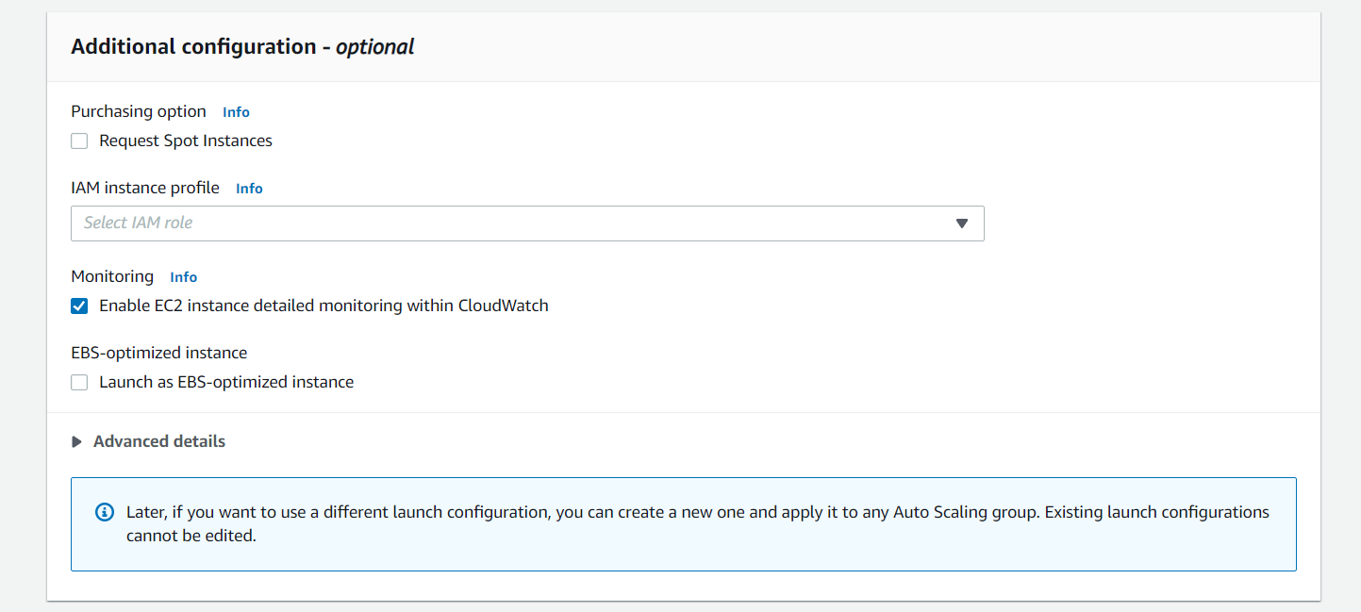

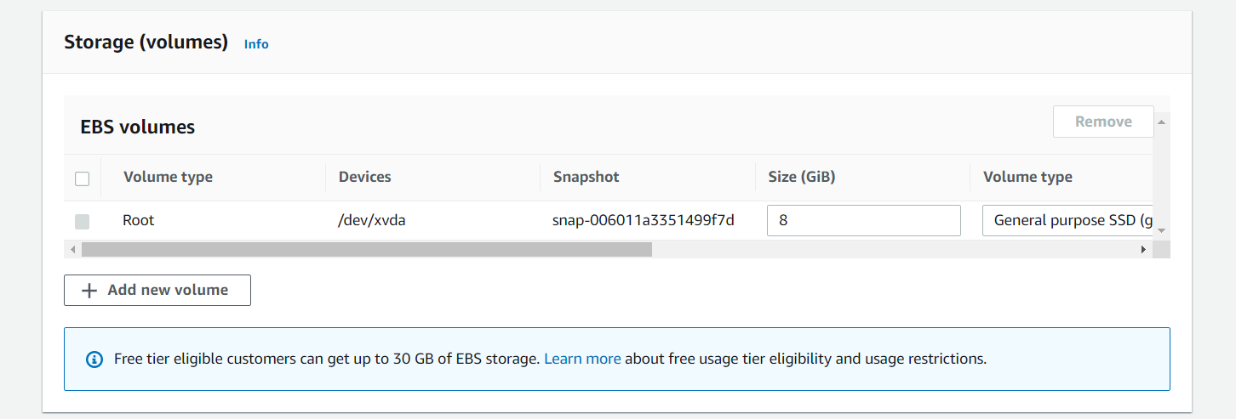

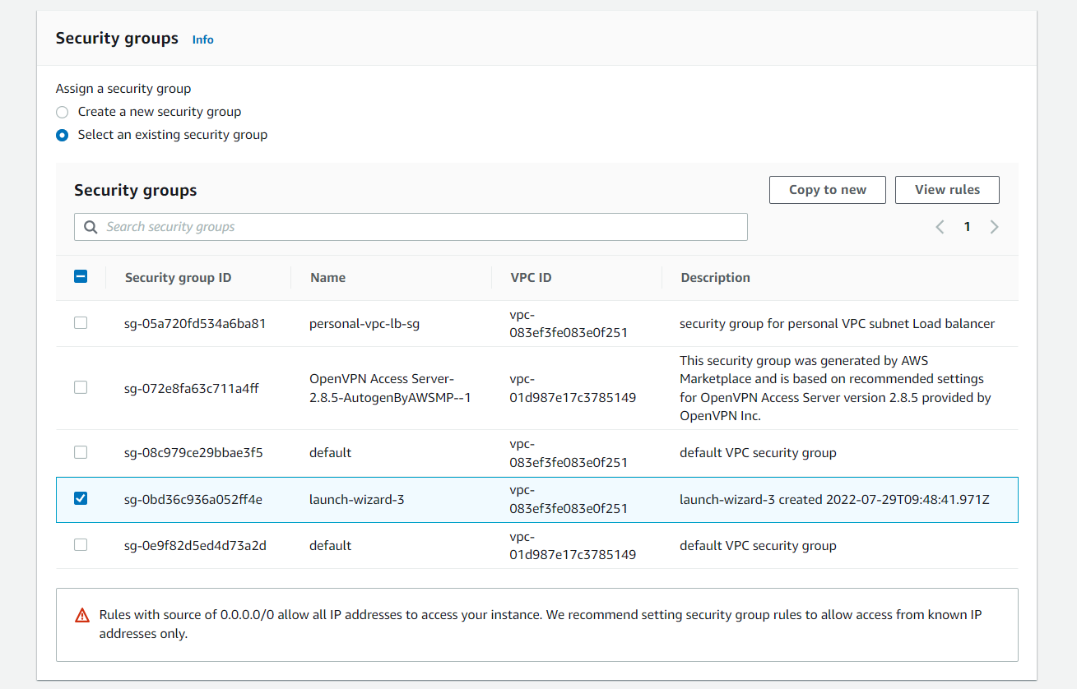

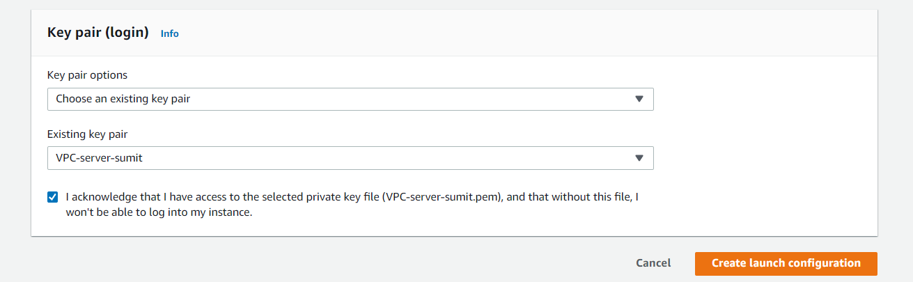

1. Created an auto scaling group using launch dynamic configuration by providing the created launch configuration.

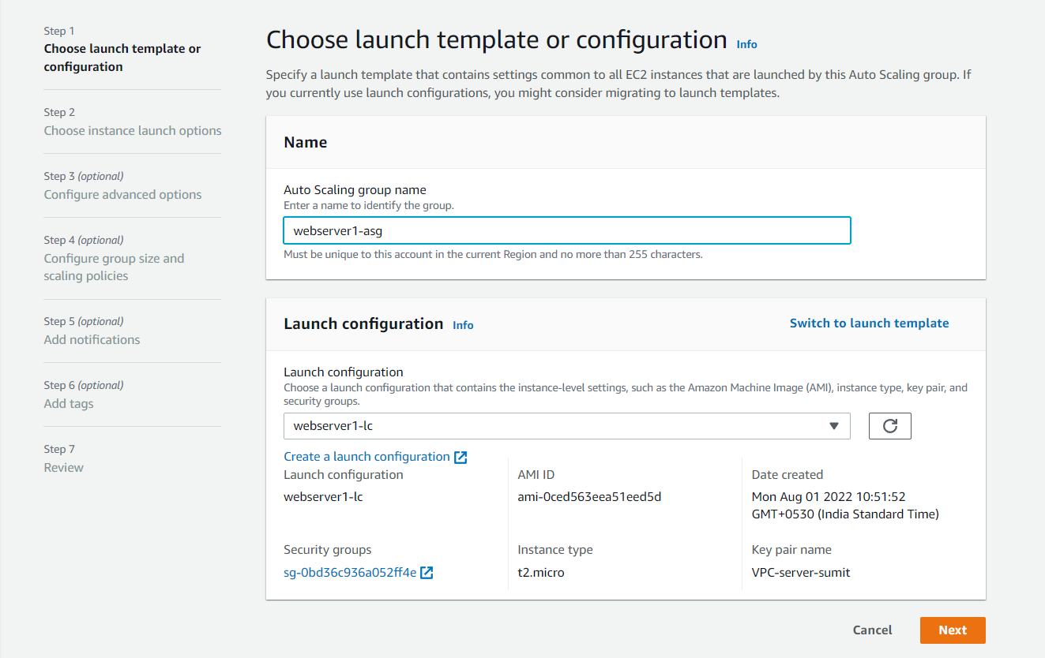

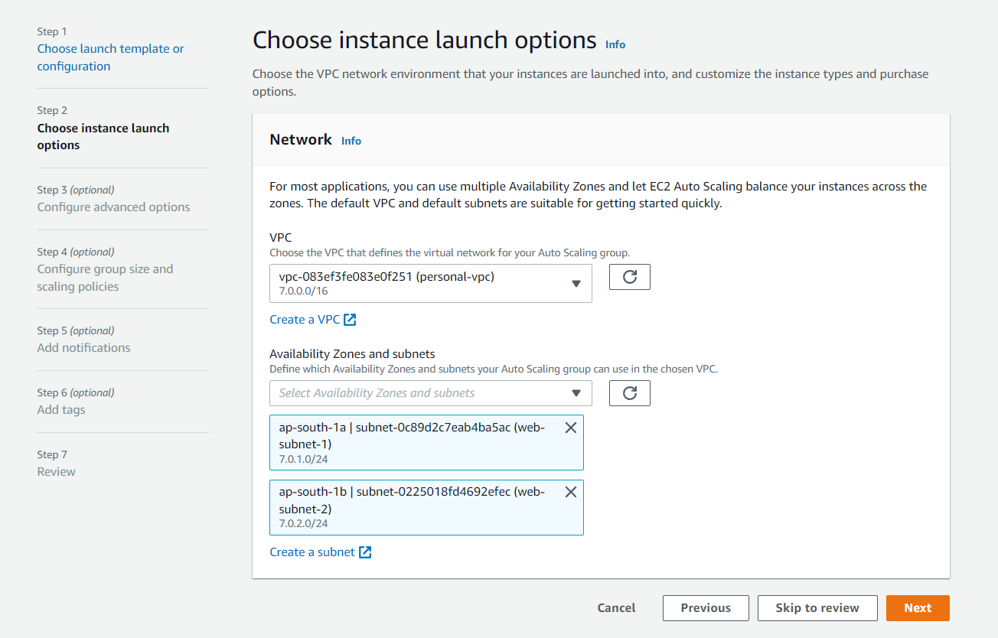

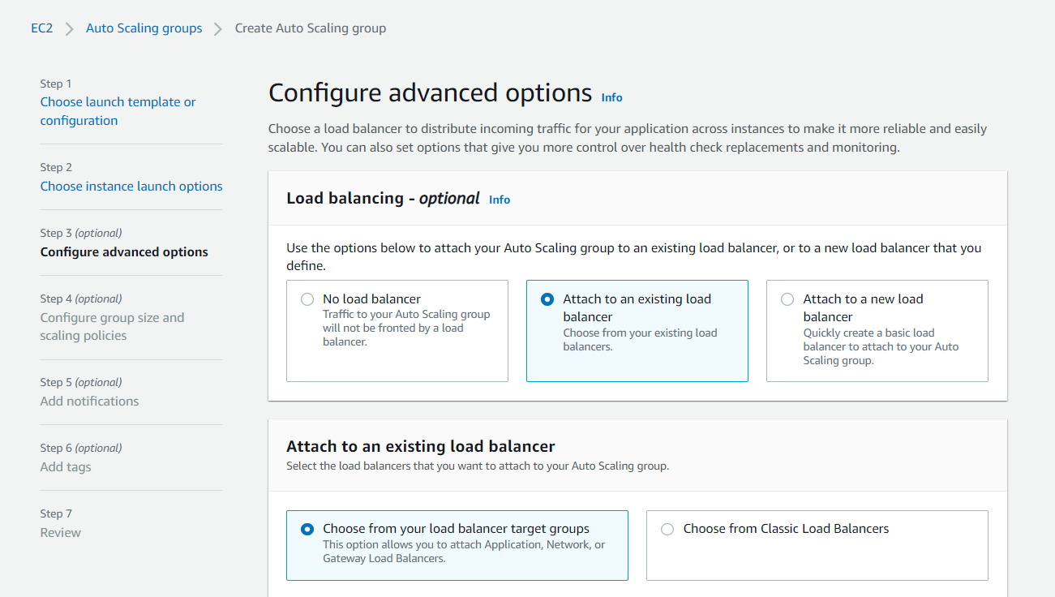

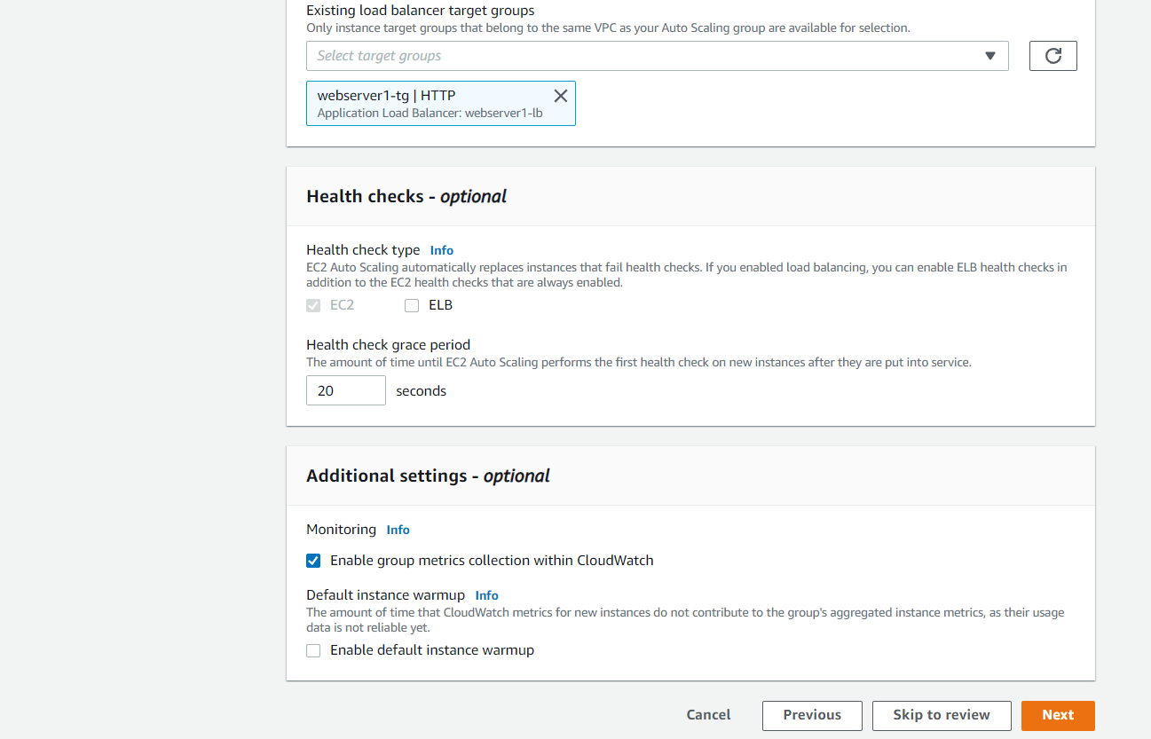

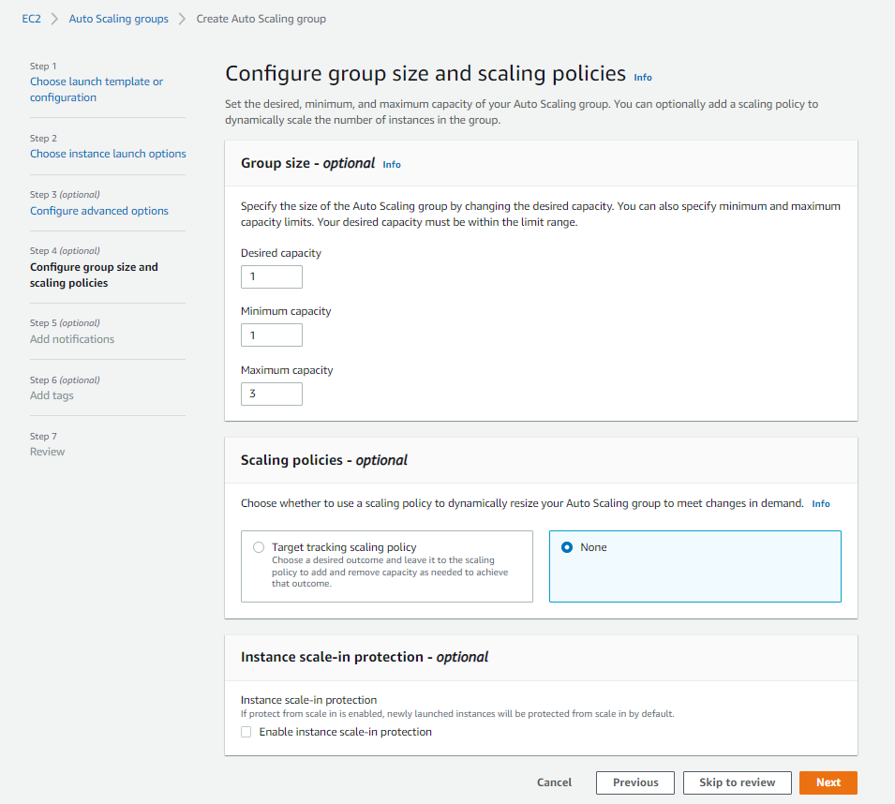

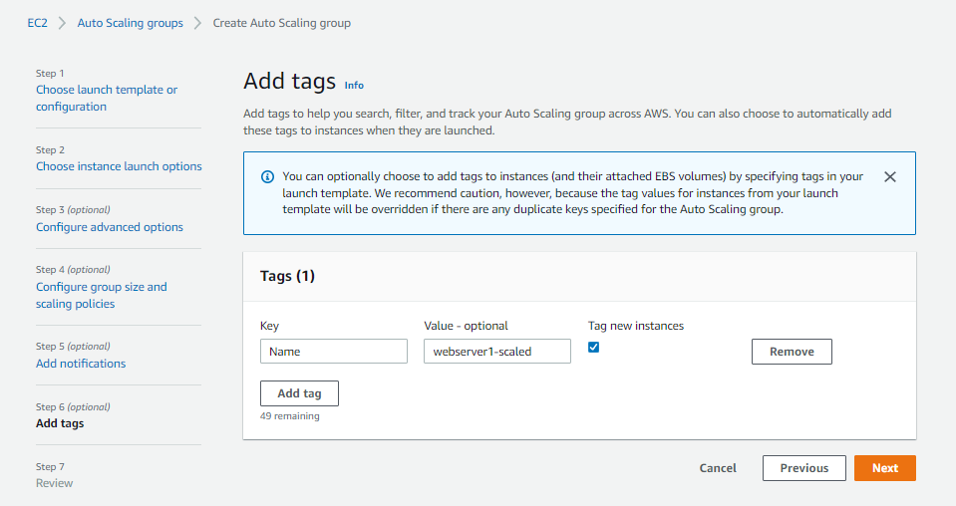

When auto scaling group will be created then by default an instance using the image created will be launched in the backend.

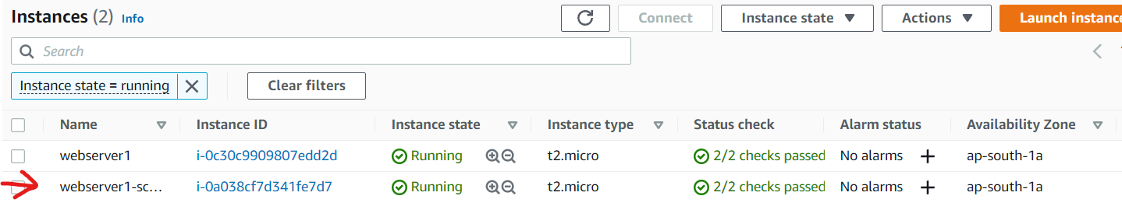

1. Added a record in route table of my domain for the web server load balancer.

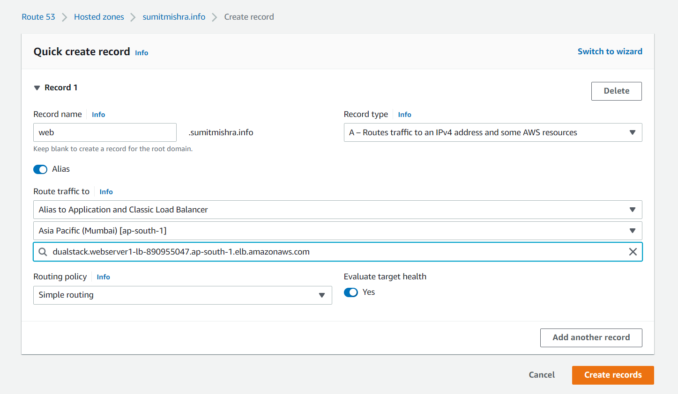

1. Then I created an SSL certificate for the webserver using AWS certificate manager in the same way as I did for “personal-vpc-lb” (metioned earlier).



As we can see here the SSL certificate is enabled for https://web.sumitmishra.info .

1. Created two Cloud watch alarms using the auto scaling group I just created named as “webserver1-asg” one for scaling out and another for scaling in.

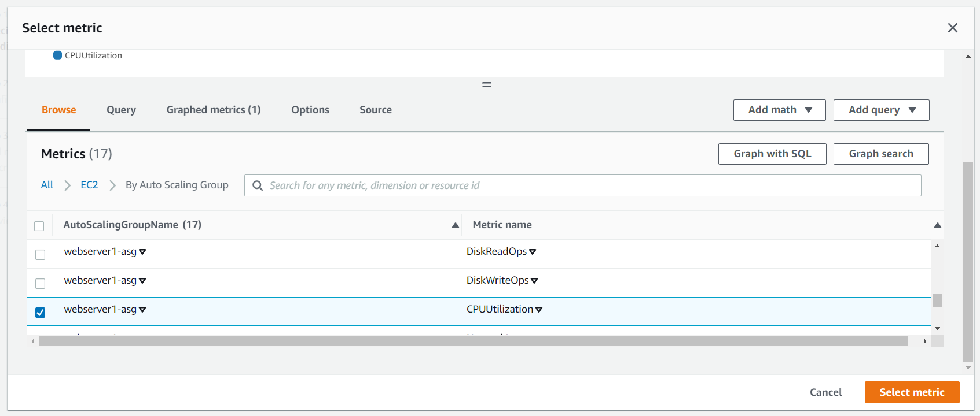

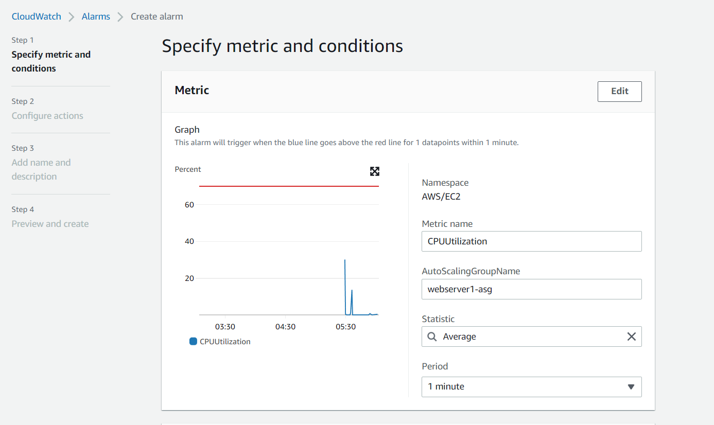

For scale-out

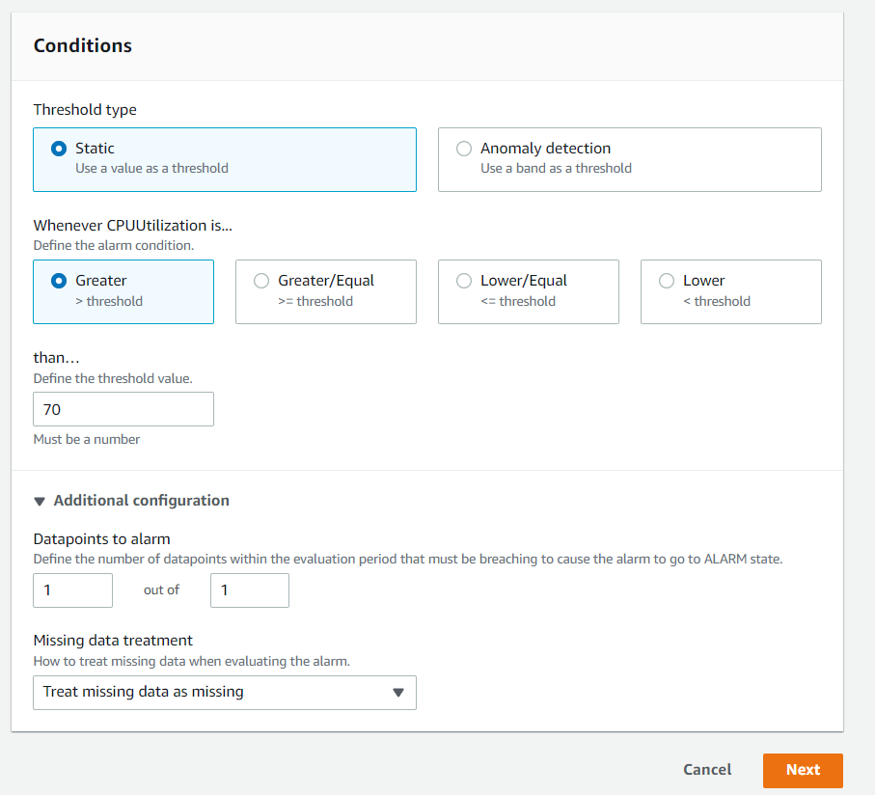

For scale in

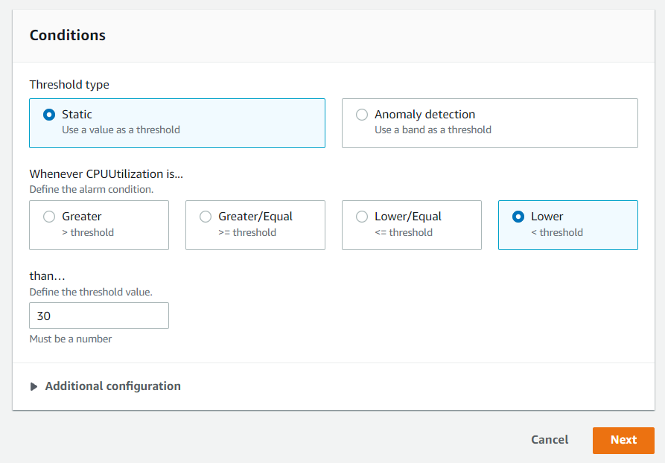

Alarms created :

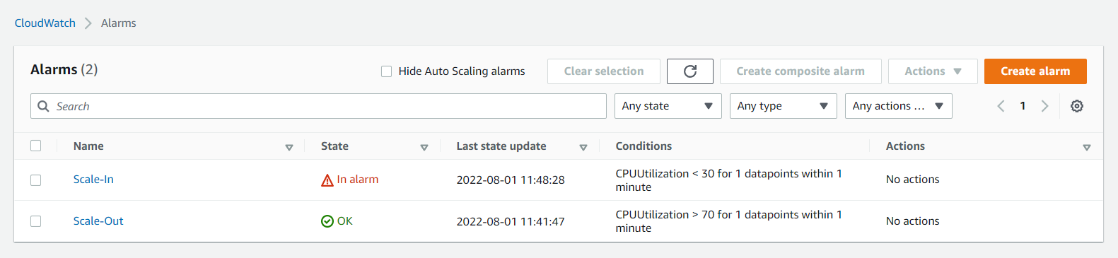

1. Then I created two dynamic scaling policies for scaling in and scaling out operation, and attached the alarms to respective scaling policies.

For scale-in:

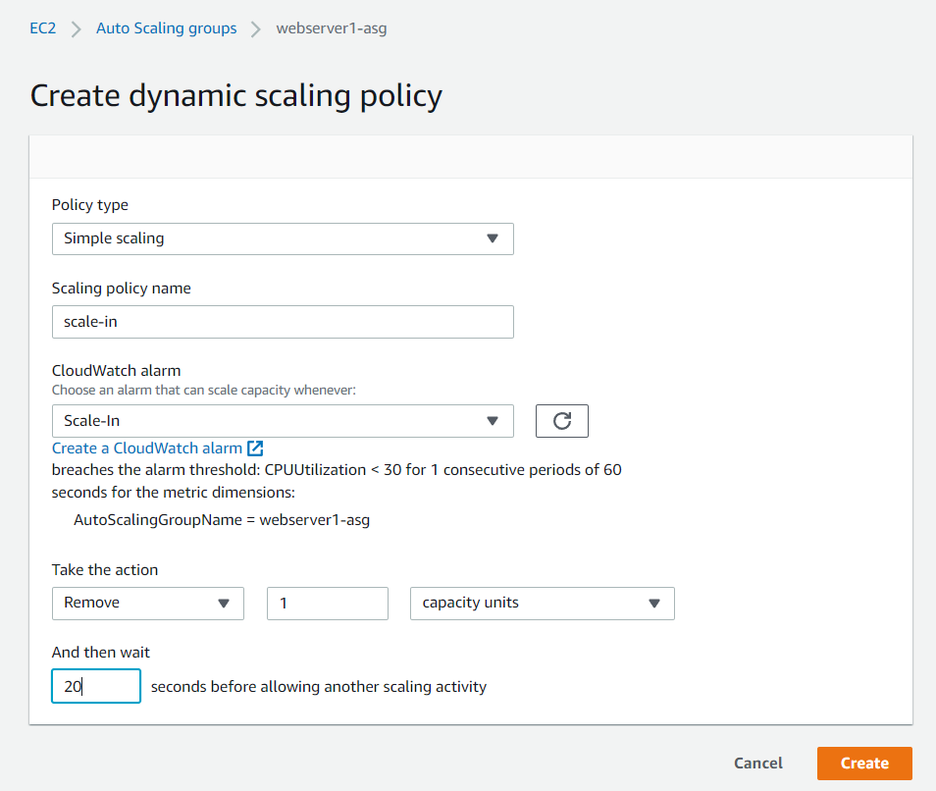

For scale-out :

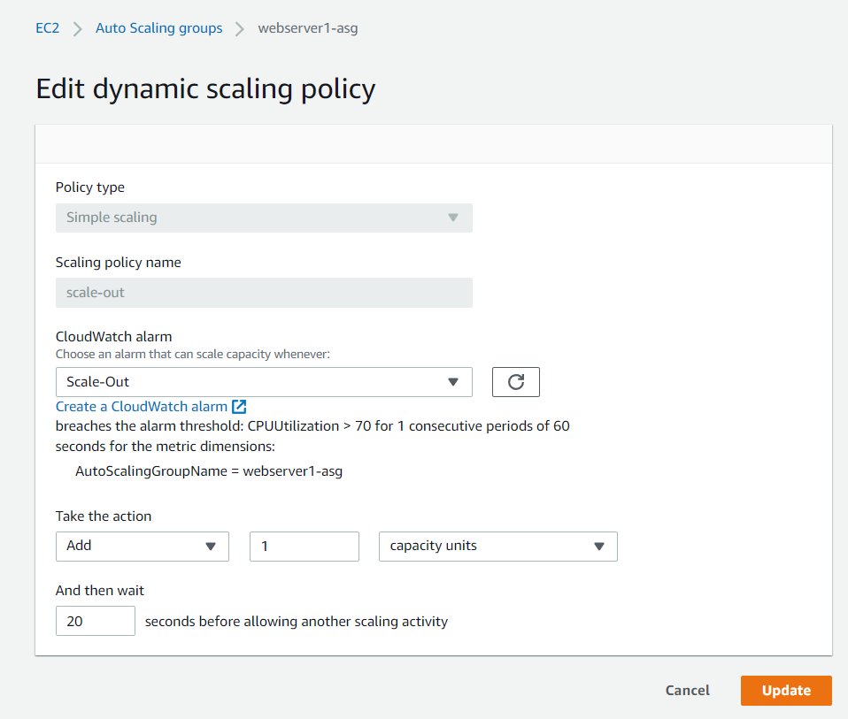

1. Then I increased the CPU utilization to 99% by typing the command “yes /dev/null &” then I typed “top” to see the utilization table.

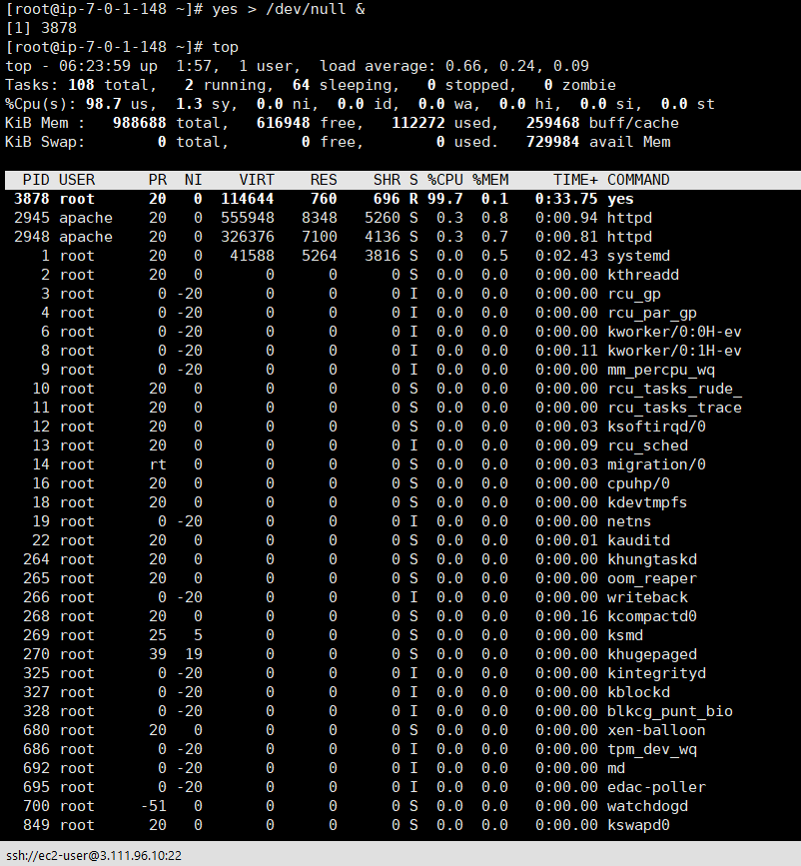

Here, we can see that CPU utilization percentage is 99.7% and scale-out alarm is triggered.

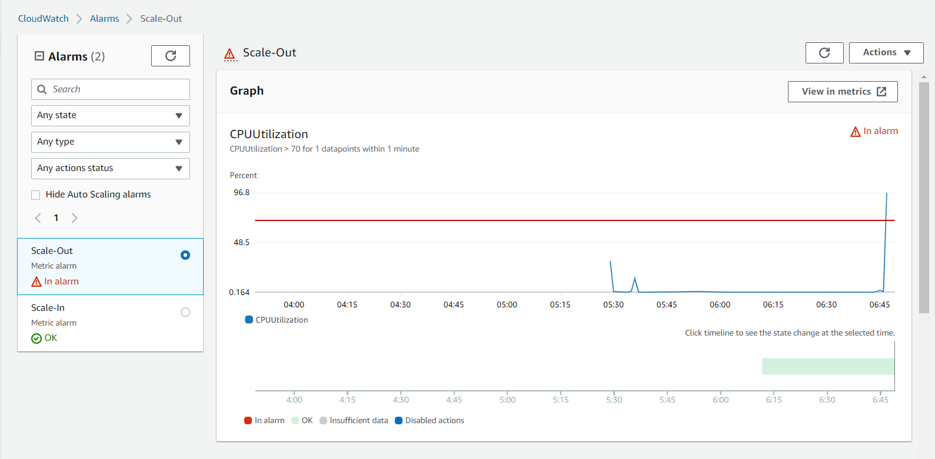

1. In the backend, servers started to deploy automatically to manage the traffic of CPU.

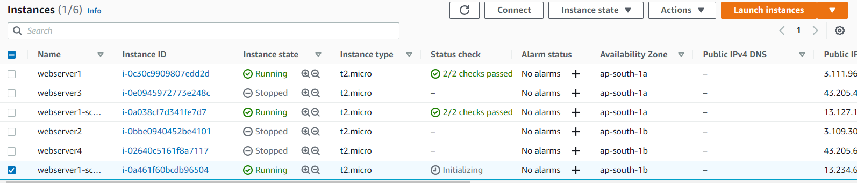

1. After that I decreased the CPU utilization of the server using the command “killall -p yes”. Then used “top” command to get the metrics.

We can see that CPU utilization has dropped close to 0%.



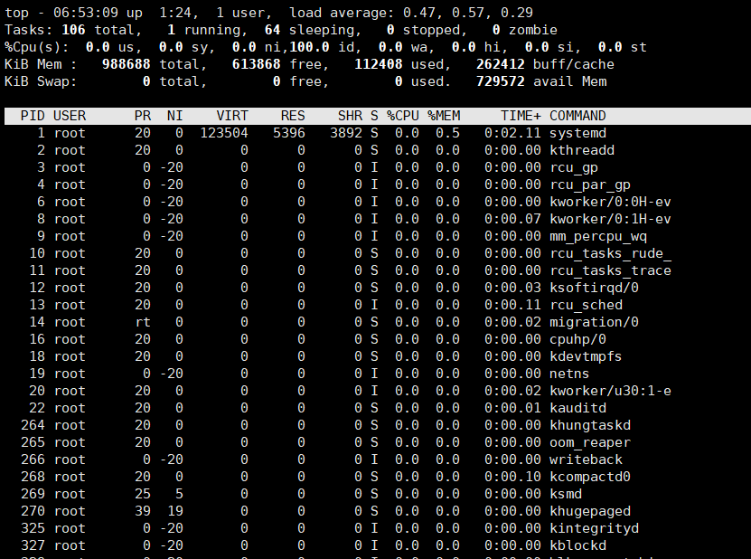

We can see that the scale in alarm has been triggered in the alarm section.

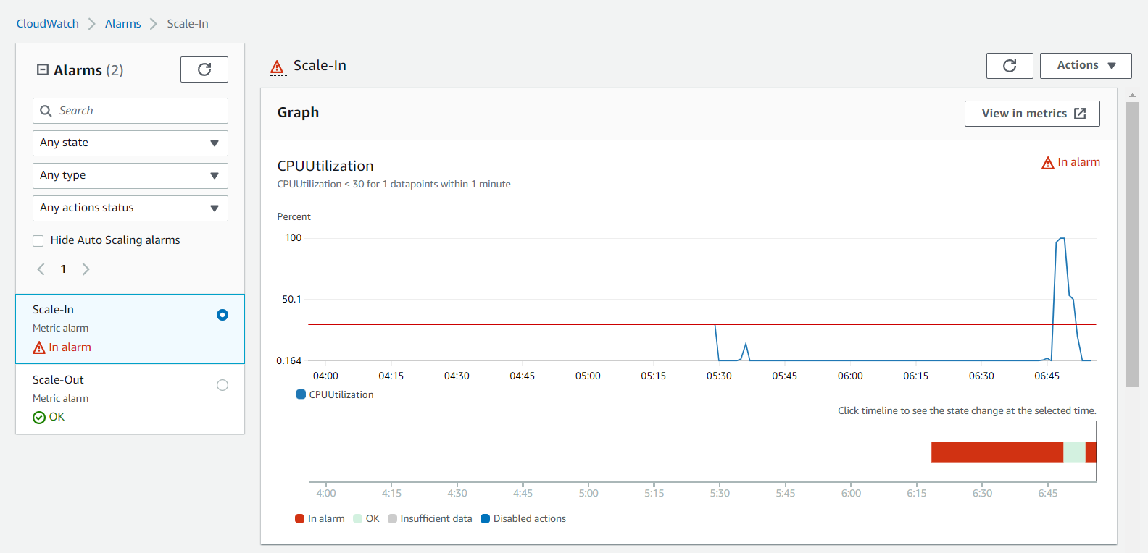

1. In the backend, the allocated servers started to terminate.

